Migration Tool User Guide

1. When entering website of “Test Case Migration Tool”, you should log in the system with domain credentials for authentication.

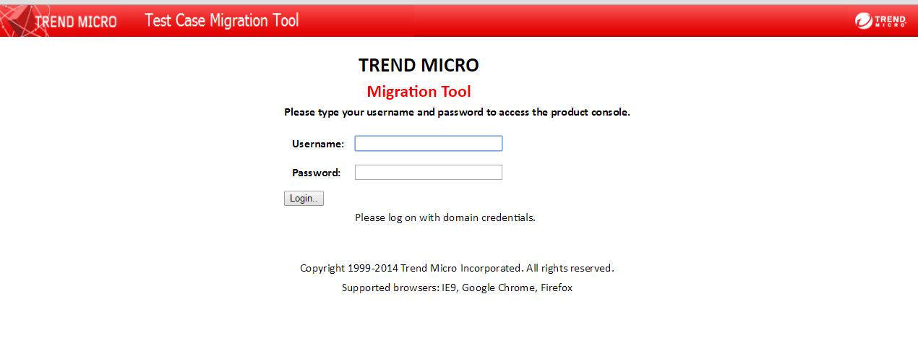

2. After logging in successfully, click the button “Go to Migrate Tests”

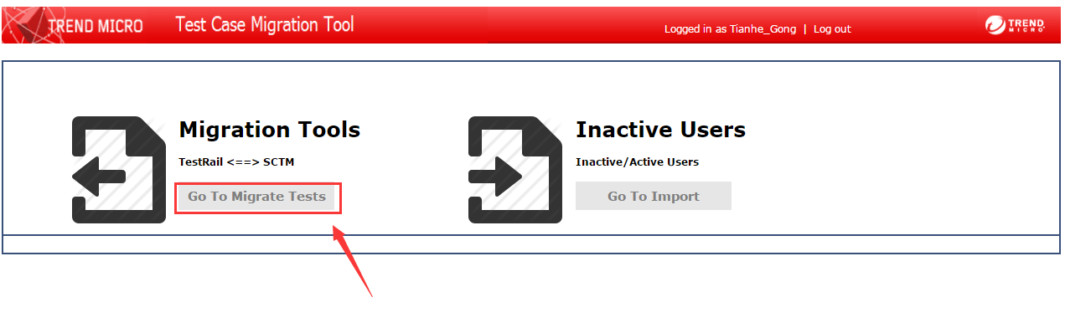

3. If you want to migrate test cases from SCTM to TestRail, the first tab should be chosen. Then, you need to select the project from SCTM, the mode of TestRail projects (multiple test suites, baseline supported or single repository) and the project name after migrating.

Clicking the button “Import”, the migration is started and the process information is shown.

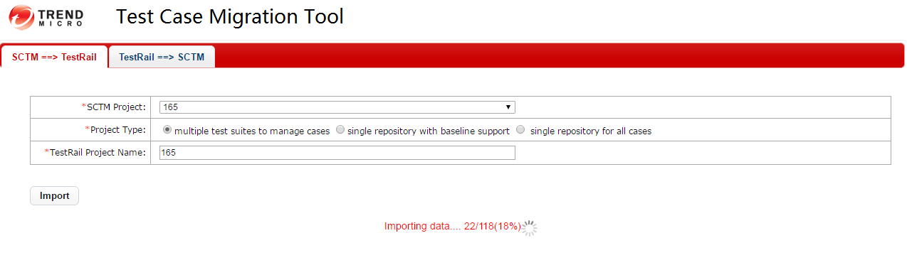

4. When the migration ends, a dialog is shown. You can access the new project in TestRail now.

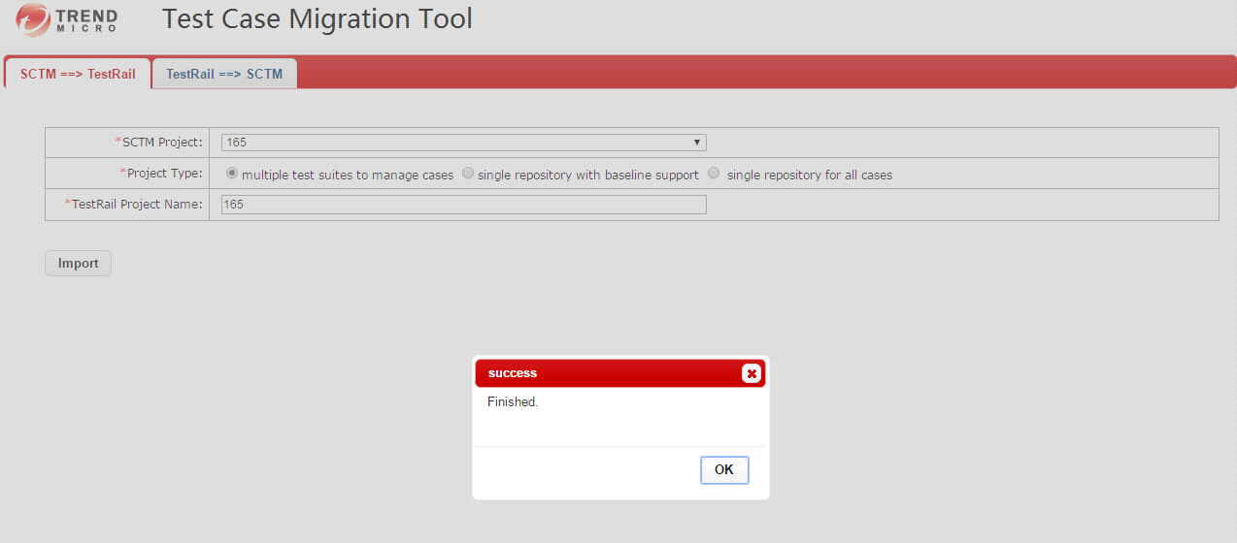

5. If you have typed a project name which exists in TestRail already, the tool gives a hint and stops the migration.

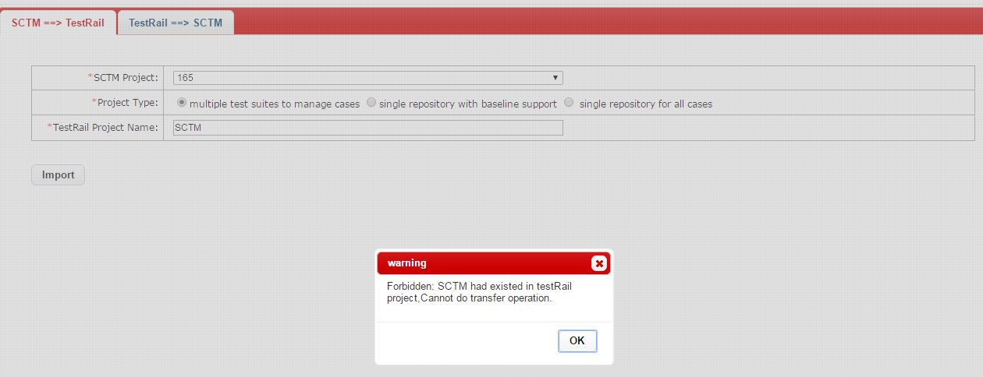

6. If you want to migrate test cases from TestRail to SCTM, the second tab should be chosen. Then project from TestRail should be selected and project name after migration should be inputted. Next, you should choose the product in SCTM for each suite(container). If you want to use all the same product for each suite, select the radio called “select one product for all containers” and choose one product. If not, choose the second radio named “select products respectively” and choose different products for every suite respectively in table “Product Assignment”.

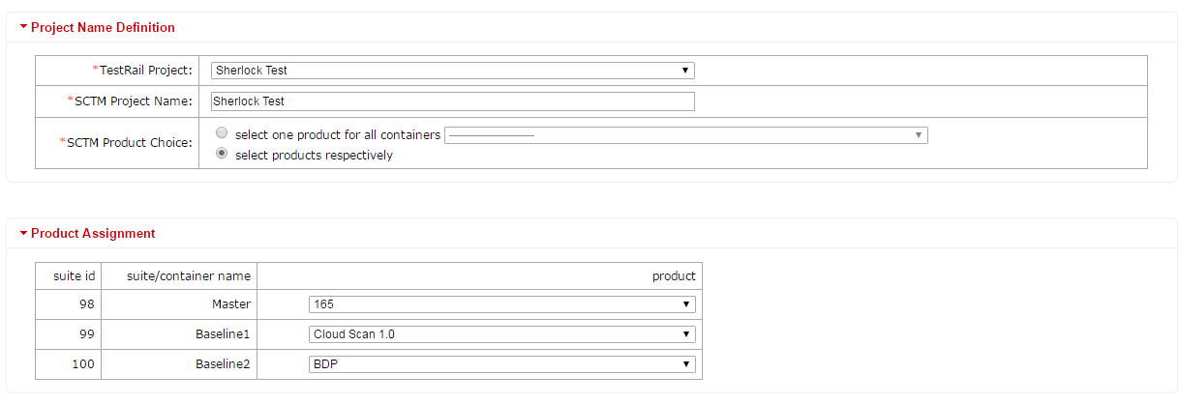

7. Afterwards, you should assign groups for the new project. In table “Group Assignment”, green rows present the groups which you are in and have enough permission for this migration. Red lines stand for the groups which you are in yet not enough permission for migration projects. Furthermore, black ones are groups you are not in. When migrating a project, at least one green line should be selected, or the migration is not allowed.

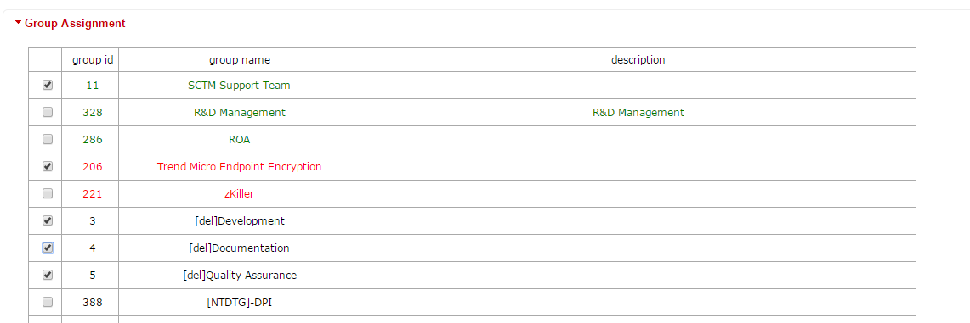

8. Click “Import” button, the migration will be conducted and the process information is shown.

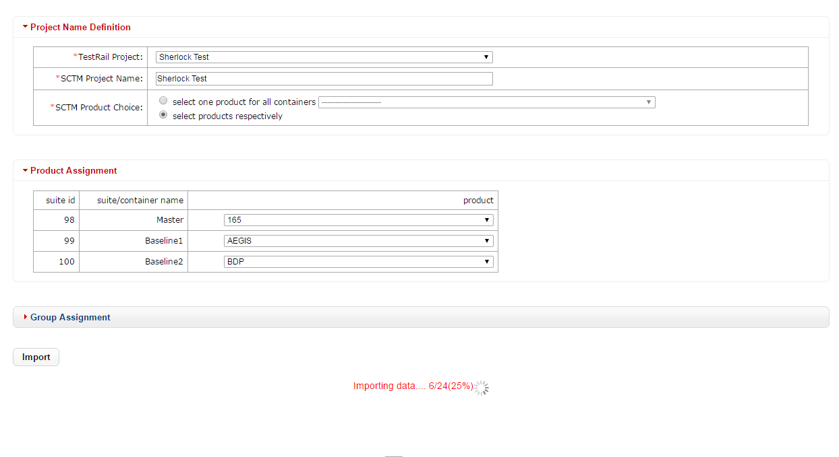

9.When the migration ends, a success dialog is shown, and you can access the project in SCTM now.

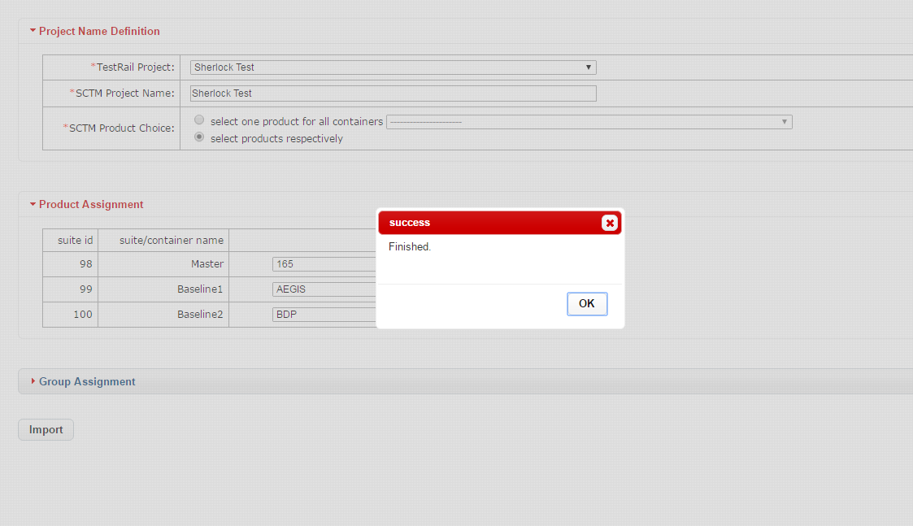

10. If an error occurs, such as the project name has already existed in SCTM, the tool will give a hint and stop this migration.

